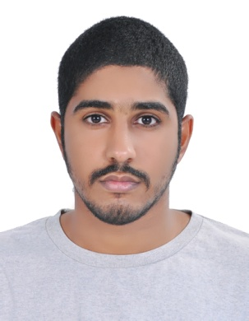

* Name: sadeq Nabeel
* Surname :Alfandi
* CPR: 000507156
* Nationality: Bahrain
* Marital status: Single
* [Tel:](Tel:38822710) 38846300

**Education:**

|  |  |  |
| --- | --- | --- |
| 1 | hamed town secondary School for boys | From: hamed town  To :2015-2018 |

**Language**:

* Arabic / English

Interests:

* Writing& reading
* Use computer & internet